Joseph Kawamoto

CS-255 23EW1

Professor Steven Stefanelli

14 October 2023

# CS 255 System Design Document Template

## UML Diagrams

### UML Use Case Diagram

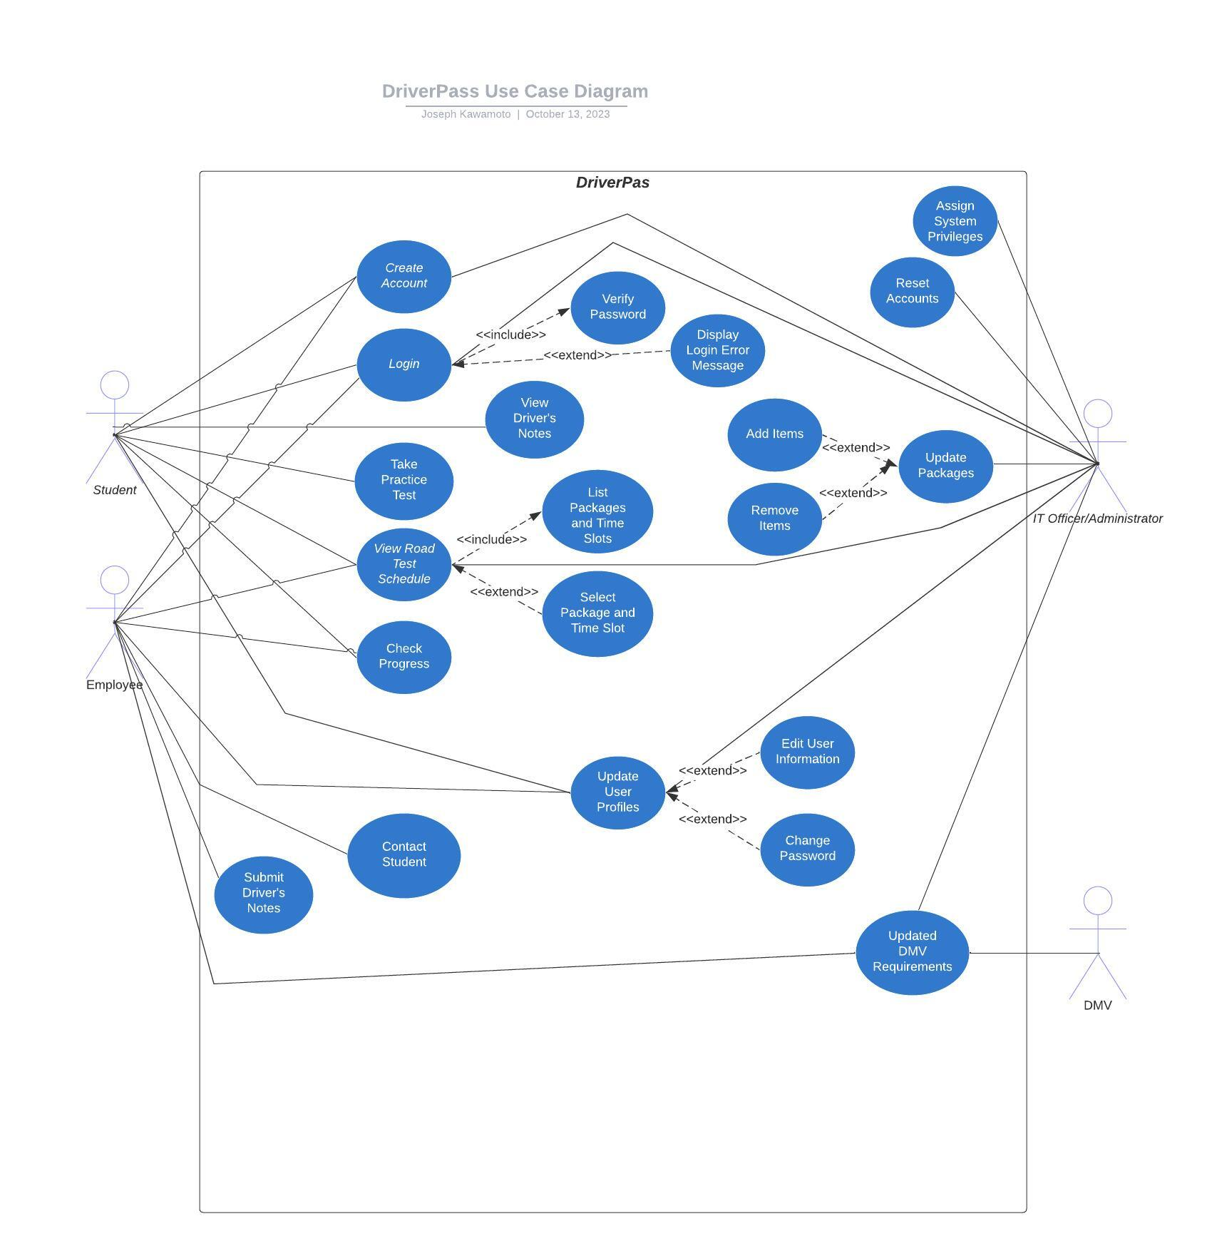

### UML Activity Diagrams

### 

### UML Sequence Diagram

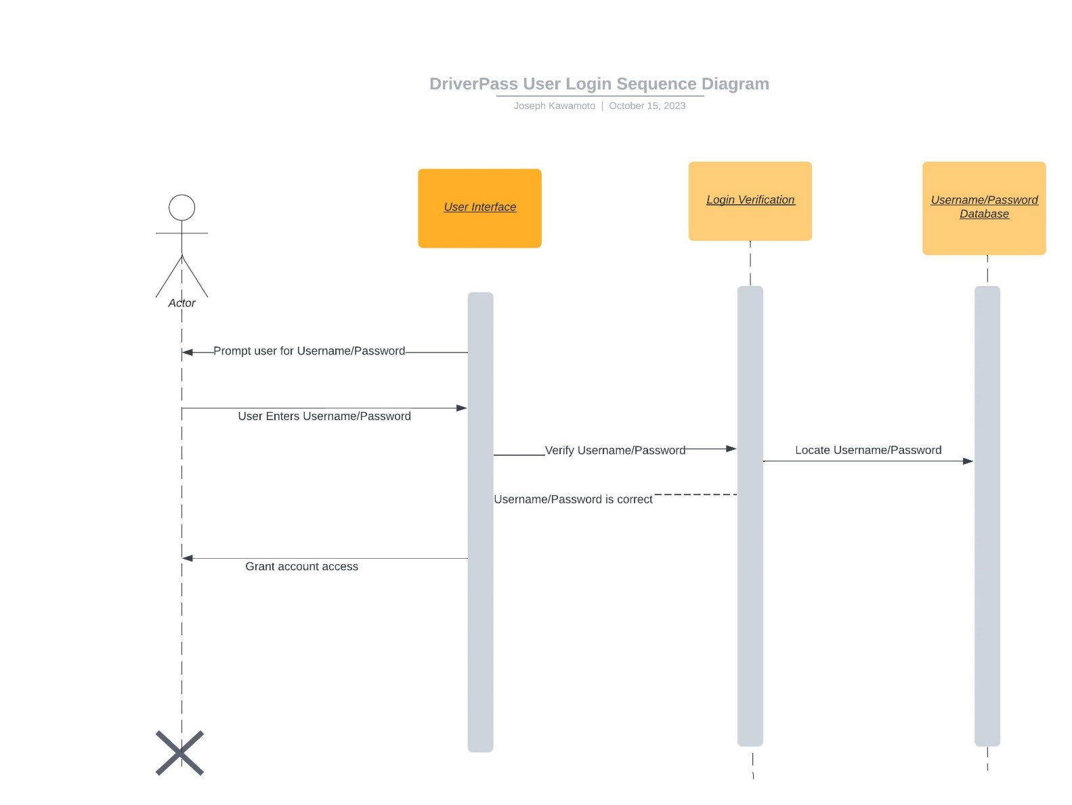

### UML Class Diagram

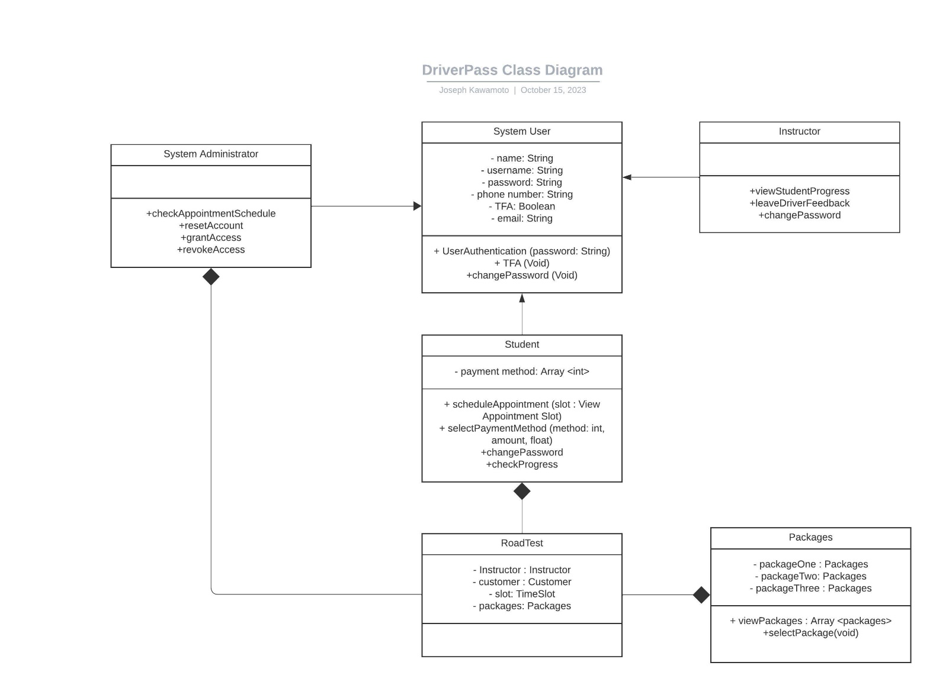

## Technical Requirements

Hardware requirements for the DriverPass system include web servers for hosting the application and database servers for storing user information, course data, and test scores. Administrator and employee workstations with fast internet connectivity are essential to managing and maintaining the system.

Software requirements include operating systems for the employee workstations, IDEs to build the framework of the system, and a database management system such as MySQL to store and handle data. HTML can also be used to secure user information. While back-end programs like C++ or Python can be used in the IDE to build the application itself.

For system infrastructure, I would suggest creating an application that is hosted on the web. This will help to cut down on the up-front costs of the system and will allow both the system and the company to scale as required.

Solid data management include regularly backing up system data and implementing data recovery mechanisms will ensure the systems reliability. We will also need to seamlessly integrate and connect to the DMV database to remain up to date on current regulations.

To make sure that the system is accessible and easy to use, we should also invest in system analytics tools to track user behavior and assess how the system is performing. These tools will provide us with valuable insights on how users are interacting with the system and what areas need to be improved.

Ensuring that users understand and know how to work with the system is essential. With that in mind, it is important that we have robust user support in place. This includes system documentation and user training materials that are available to instructor and student alike. It would also be helpful to have a helpdesk and support ticket system in place for user assistance.